**OVERVIEW OF RASPBERRY PI 2**

The Raspberry Pi2ModelB is a compact, cost-effective, and versatile single-board computer developed by the Raspberry Pi Foundation. It is equipped with a 900 MHz quad-core ARM Cortex-A7 processor, 1 GB of LPDDR2 RAM, and a 40-pin GPIO header, providing a strong foundation for running general-purpose software, controlling hardware interfaces, and performing moderate levels of computation. Originally designed to promote computer science education, the Raspberry Pi 2 has become widely adopted in hobbyist projects, including robotics, IoT, and space-related experiments.

For a hobby satellite project, the Pi 2 offers several compelling capabilities, especially for processing and data management tasks. However, deploying it in space introduces engineering challenges related to its environmental durability, power efficiency, and real-time control limitations, which must be weighed carefully.

Below is an image of the Raspberry pi 2 board:

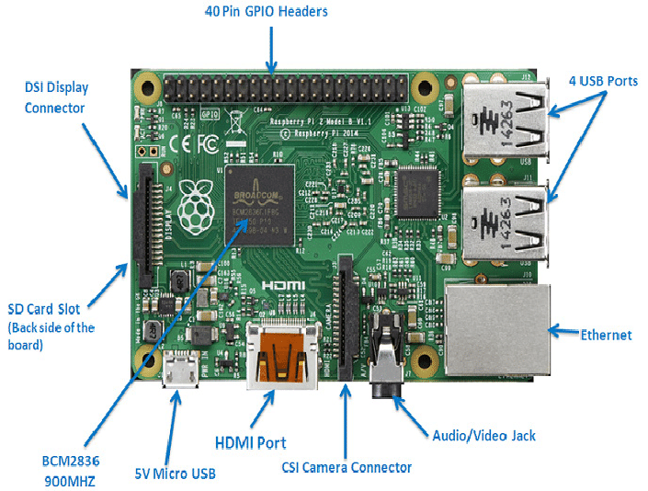

*Figure 1: Raspberry pi 2*

**KEY FEATURES**

* **Quad-Core ARM Processor**: The 900 MHz Cortex-A7 processor can run multitasking applications and handle moderate computational loads. This makes it capable of performing edge processing tasks such as image filtering, compression, or telemetry formatting.
* **1 GB RAM**: With 1 GB of RAM, the Pi 2 can manage larger data buffers, run multiple processes simultaneously, and support more demanding software packages compared to microcontrollers.
* **Linux Operating System Support**: The Pi 2 can run full Linux distributions, like Raspberry Pi OS (formerly Raspbian), Ubuntu MATE, or specialized OS images, allowing use of high-level programming languages (Python, C/C++, Java), libraries (OpenCV, NumPy), and software packages for networking and data processing.
* **GPIO and Peripheral Support**: The 40-pin GPIO header allows easy connection to external sensors, actuators, and communication modules (e.g., GPS, gyroscopes, RF transmitters), giving users direct control over hardware.
* **Camera and Display Interfaces**: With a CSI (Camera Serial Interface) port and DSI (Display Serial Interface), it can interface with the Raspberry Pi Camera Module for onboard imaging, and output data to a screen for debugging or ground-based visualization.

**ADVANTAGES**

1. **High Processing Power**: Compared to traditional microcontrollers, the Raspberry Pi 2 offers significantly more processing power. This allows it to run image-processing algorithms, compress large amounts of sensor data, or even perform light machine learning inference tasks, which are often useful in satellite-based Earth observation or autonomous onboard decision-making.
2. **Full Linux Environment**: Running a full OS enables developers to use familiar tools and languages, set up cron jobs, perform parallel processing, and use open-source libraries. It also supports multitasking and high-level abstraction, which simplifies development and debugging.
3. **Camera and Imaging Capability**: The Pi 2 can connect to a high-definition camera module (e.g., 5MP Pi Camera) and process or store images locally. This is especially useful in CubeSat or CanSat missions that require visual monitoring or Earth imaging.
4. **Rich Peripheral Ecosystem**: With USB, UART, I2C, and SPI support, it can interface with many types of sensors and communication modules, making it a flexible platform for experimentation and integration.
5. **Large Developer Community**: There is extensive online support, tutorials, libraries, and community examples available, which greatly reduces the development time and simplifies troubleshooting.

**DISADVANTAGES**

1. **Not Radiation-Hardened**: Since Raspberry Pi 2 is a commercial off-the-shelf (COTS) product, it lacks any radiation tolerance. In space, cosmic rays can cause bit-flips or logic errors, especially in RAM and storage, which may crash or corrupt the system.
2. **High Power Consumption**: Drawing about 700–900 mA at 5V, the Pi 2 is relatively power-hungry for a small satellite system. This increases the demand on the power subsystem, which is usually limited in both solar panel area and battery size.
3. **Thermal Management Concerns**: The Raspberry Pi 2 can overheat under heavy load or in poorly ventilated enclosures. In orbit, the absence of convection cooling makes thermal control difficult, and overheating could affect reliability or lifespan.
4. **No Real-Time Operation**: Linux is not a real-time operating system (RTOS), so tasks like motor control or precise sensor sampling cannot be guaranteed to occur at fixed intervals. This limits its usefulness for flight-critical timing-sensitive tasks.
5. **Storage Fragility**: The microSD card used for booting and storage is vulnerable to corruption from sudden power loss or radiation. If the card fails, the system may become completely unbootable unless redundancy is built in.

**BEST USE CASES IN A HOBBY SATELLITE**

* **Ground-Based Testing and Development**: Before deploying to space, the Raspberry Pi 2 is excellent for developing and testing satellite software on the ground. Its Linux OS and GPIO interface make it ideal for simulating sensor inputs and outputs, testing communication protocols, and visualizing telemetry data.
* **Onboard Imaging and Data Collection**: The Pi 2 can be used to control a camera module for capturing images during flight. It can also apply basic image processing (like resizing, compressing, or adding timestamps) before storing the data or sending it to a ground station.
* **Telemetry Formatting and Storage**: Another practical use is handling telemetry data from various sensors. The Pi 2 can aggregate, timestamp, and format this data into packets suitable for RF downlink, or temporarily store it in a buffer.
* **Secondary (Non-Critical) Onboard Computer**: In space, it’s better suited as a backup or auxiliary processor that performs non-critical tasks, such as running experiments, collecting environmental data, or logging mission metrics — while a more robust microcontroller handles vital controls.
* **Post-Processing Tasks in a High-Altitude Balloon or Suborbital Mission**: For hobbyists testing payloads on weather balloons or suborbital rockets, the Raspberry Pi 2 offers powerful computing for data processing once the payload is recovered.

**COMPARISON WITH OTHER RASPBERRY PI MODELS**

1. **Performance**

The Raspberry Pi 4 is the most powerful, with a 1.5 GHz Cortex-A72 CPU and up to 8 GB RAM, great for multitasking, data processing, and AI. However, it requires more power and cooling.The Pi 3 offers decent performance with a 1.2 GHz CPU and built-in wireless, making it a reliable option for general tasks and onboard computation.Pi 2 is a solid mid-range choice with a 900 MHz quad-core processor. It lacks wireless support but handles basic processing tasks well.

The Pi Zero 2 W is compact but surprisingly capable, performance is close to the Pi 3, suitable for lightweight applications like telemetry or simple automation.

1. **Power Consumption**

Pi Zero 2 W and Pi 2 consume less power, making them better suited for power-limited environments like balloon or satellite payloads. Pi 4 is the most power-hungry and generates heat, so it’s better for ground-based or short-duration systems.

1. **Connectivity**

Pi 3, Pi 4, and Zero 2 W have built-in Wi-Fi and Bluetooth, helpful for wireless data links. Pi 2 lacks these features, so USB dongles are needed for wireless communication.

1. **Size and Weight**

Pi Zero 2 W is the most compact and lightest, ideal for small payloads or tight enclosures. Pi 2, 3, and 4 are larger but offer easier access to ports and more expansion options.

1. **Cost**

Pi Zero 2 W is the most affordable, followed by Pi 2, then Pi 3. Pi 4 is more expensive, especially with higher RAM.

1. **GPIO and Storage**

All models use the same 40-pin GPIO layout, which ensures hardware compatibility. All boot from microSD cards, but Pi 4 also supports USB booting.

**CONCLUSION**

The RaspberryPi2 Model B is a flexible and affordable computing platform with several features that make it appealing for student-led or hobbyist satellite missions. While it is not recommended for core flight control or critical operations in space due to its lack of radiation protection and real-time capabilities, it is highly effective as a supporting onboard processor for tasks like data logging, imaging, or communications prep. Used in conjunction with a low-power, real-time microcontroller such as an STM32, it can help offload high-level computation and significantly expand the functionality of a small satellite system.